Exercises_1_script.R

hansf

2020-09-28

library(tidyverse)

## -- Attaching packages ------------------------------------------------------- tidyverse 1.3.0 --

## v ggplot2 3.3.2 v purrr 0.3.4  
## v tibble 3.0.3 v dplyr 1.0.2  
## v tidyr 1.1.2 v stringr 1.4.0  
## v readr 1.3.1 v forcats 0.5.0

## -- Conflicts ---------------------------------------------------------- tidyverse_conflicts() --  
## x dplyr::filter() masks stats::filter()  
## x dplyr::lag() masks stats::lag()

library(ISLR)  
Hitters = Hitters  
  
# General Graph Grammar  
  
  
# ggplot(data = <DATA>) +   
# <GEOM_FUNCTION>(   
# mapping = aes( < MAPPINGS > ),   
# stat = < STAT > ,   
# position = < POSITION >   
# ) +   
# < COORDINATE_FUNCTION > +   
# < FACET_FUNCTION >   
   
 # Question 1:  
 ## Name the aesthetics, geoms, scales, and facets of the above visualisation. Also name any statistical transformations or special coordinate systems.  
   
  
# histogram of the distribution of salary  
hist(Hitters$Salary, xlab = "Salary in thousands of dollars")

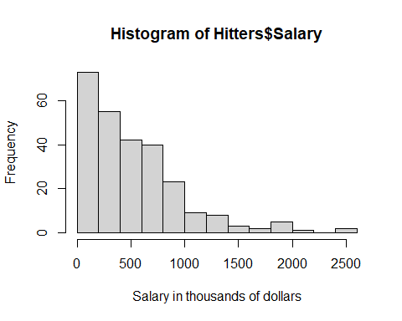

#1. Aesthetic  
#2. Geoms  
#3. Scales  
#4. Facets  
  
  
barplot(table(Hitters$League))

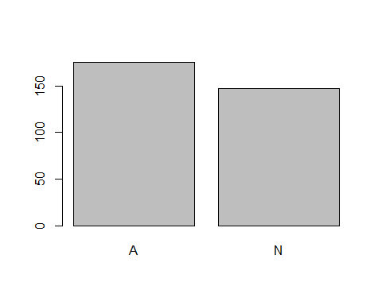

#1. Aesthetic  
#2. Geoms  
#3. Scales  
#4. Facets  
  
homeruns_plot <-   
 ggplot(Hitters, aes(x = Hits, y = HmRun)) +  
 geom_point() +  
 labs(x = "Hits", y = "Home runs")  
  
homeruns_plot

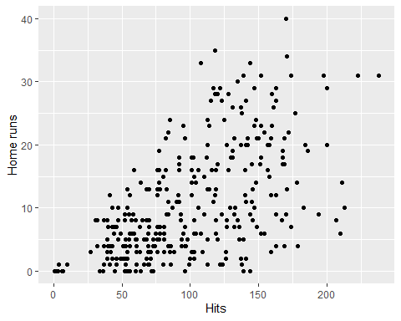

homeruns_plot +   
 geom_density_2d() +  
 labs(title = "Cool density and scatter plot of baseball data") +  
 theme_minimal()

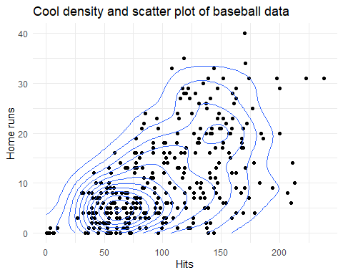

# Question 1:  
## Name the aesthetics, geoms, scales, and facets of the above visualisation. Also name any statistical transformations or special coordinate systems.